1. Nosql Databases

A **NoSQL** database provides a mechanism for storage and  retrieval of data that is modeled in means other than the tabular relations used in relational databases. It is a generic Data model.

NoSQL analytics systems support runtime type identification and conversion so that custom business logic can be used to dictate analytic treatment of variation. Data is stored in single tables as compared to joining multiple tables.

Example:

**MongoDB** is an open-source document database and leading NoSQL database. MongoDB is written in C++. MongoDB is a cross-platform, document oriented database that provides, high performance, high availability, and easy scalability. MongoDB works on concept of collection and document.

1. Types of Nosql Databases

**Document databases** pair each key with a complex data structure known as a document. Documents can contain many different key-value pairs, or key-array pairs, or even nested documents.

**Graph stores** are used to store information about networks of data, such as social connections. Graph stores include Neo4J and Giraph.

**Key-value** stores are the simplest NoSQL databases. Every single item in the database is stored as an attribute name (or 'key'), together with its value. Examples of key-value stores are Riak and Berkeley DB. Some key-value stores, such as Redis, allow each value to have a type, such as 'integer', which adds functionality.

**Wide-column** stores such as Cassandra and HBase are optimized for queries over large datasets, and store columns of data together, instead of rows.

1. CAP Theorem

CAP stands for Consistency, Availability and Partition Tolerance.

Consistency - This means that the data in the database remains consistent after the execution of an operation. For example after an update operation, all clients see the same data.

Availability - This means that the system is always on (service guarantee availability), no downtime.

Partition Tolerance - This means that the system continues to function even if the communication among the servers is unreliable, i.e. the servers may be partitioned into multiple groups that cannot communicate with one another.

Duplicate Copy of same data is maintained on Multiple Machines. This increases availability, but decreases consistency.

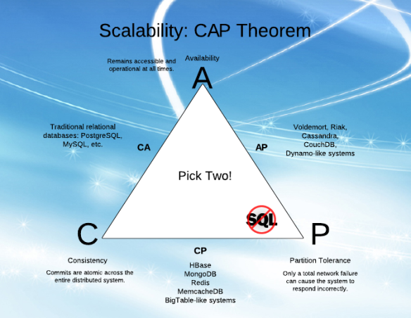

1. HBase Architecture

HBase is composed of three types of servers in a master slave type of architecture.

• Region servers serve data for reads and writes.

• HBase Master process handles the Region assignment, DDL (create, delete tables) operations

• Zookeeper maintains a live cluster state.

The Hadoop DataNode stores the data that the Region Server is managing. All HBase data is stored in HDFS files. The NameNode maintains metadata information for all the physical data blocks that comprise the files.

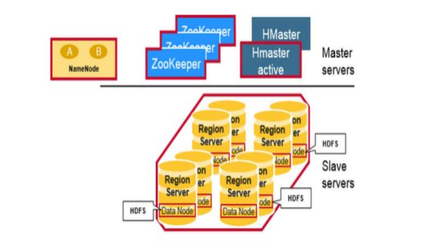

1. HBase vs RDBMS

|  |  |
| --- | --- |
| **RDBMS** | **HBASE** |
| RDBMS is row-oriented databases | HBase is a distributed, column-oriented data storage system |
| RDBMS tables have fixed-schema | Hbase tables do not have fixed-schema |
| RDBMS tables guarantee ACID properties | Hbase tables guarantee consistency and partition tolerance |
| RDBMS uses SQL (Structured query Langauge ) to query the data | Hbase uses Java client API and Jruby |